Offer
Fund Raise: $10M Total Shares Issued: 1,000,000,000
Investment:
 | Capital | Equity | Shares | Share Price / Unit | Appreciation | Valuation
Round 1 | $10m | 40% | 400m | $0.025 |  | $25m

Overview
Owners and operators of multiple cannabis cultivation, manufacturing, distribution, retail, and delivery businesses are forming a new operating group to manage, optimize, and expand cannabis operations in the state of California.

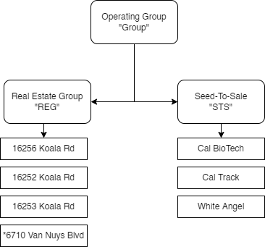
The restructuring of current operations
will provide a streamlined, efficient, and
robust generational revenue operation
that is able to optimize profits across
the entirety of the cannabis supply
chain (Seed-To-Sale).

The new operating group will manage
two divisions that focus maximizing
shareholder value.
The Real Estate division focuses on
the development of the Groups
investment properties and maintaining
compliance and operational capacity.

The Seed-To-Sale division focuses on
Cannabis state compliance, product
development and distribution, and
the sales and marketing of branded
cannabis assets.

Seed-To-Sale
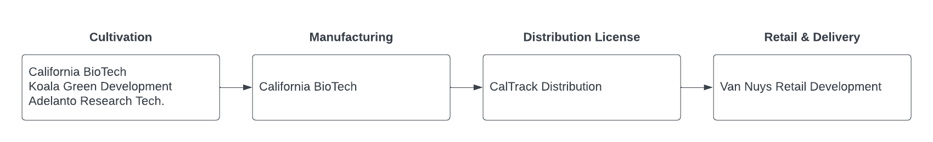
Investment and development of the Seed-To-Sale infrastructure has already been completed with use a portion of investment being directed to the completion of the Retail storefront.
The Retail storefront enables the Group to maximize its profitability by expanding margins to over 50%.
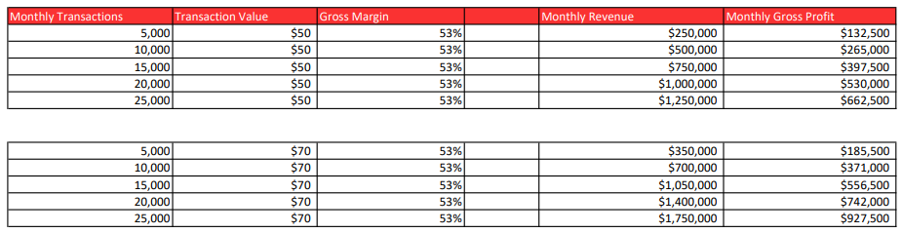

Real Estate
Cultivation and manufacturing facilities are in the High Desert region with Retail operations located at a premium location in Van Nuys, CA.
Investment will be utilized to acquire the current cultivation and manufacturing facilities as well as expand operations to increase output by 30% - 40%+ which will lead to an increase in revenue by an estimated $1M - $2M+ annually.
The Adelanto commercial real estate market where our core operations are located has exploded in the last 15 years according to Coldwell Banker Commercial:
- Sale price PSF has increased 722%
- Lease rates have increased 917%
- Land value has increased 1286%
Additionally, the residential real estate in the High Desert has appreciated an average 10% YoY over the last 5-years.
Investors will find that our real estate portfolio will offer a hedge on inflation and an insurance to the totality of their investment

Operating Group
Consolidated administration, finance, sales, and marketing at the operating group level will streamline revenue operations and greatly reduce expenses.
Portion of investment will be utilized to upgrade our IT infrastructure, software (ERP, CRM, etc.)

Consolidate Financials
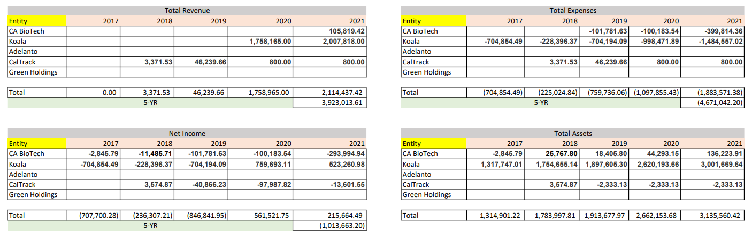

Growth Operations
After formation of the operating group and the optimization of consolidated operations, the Group will seek acquisition opportunities that provide revenue and market share growth.
Cultivation – Adelanto and the High Desert offers untapped opportunities that immediately increase cultivation capacity and revenue generation.
There are turn-key licensed operations on the market that would produce an additional 1,000 lbs/month or nearly $2M+ /month revenue for our consolidated operations. These facilities encompass 50k+ sqft and are priced at $20M for real estate and standing business/licenses.
Delivery – There are dozens of micro-delivery services operating in Southern California which offer us low cost opportunities to acquire profit generating consumer facing businesses that our branded products can be placed in.
Manufacturing – Our existing operations and expanded capacity allows us to go out to Cannabis Brands looking for increased production for their branded products.
Real Estate – There is a wealth of cultivation and manufacturing zoned space available in the High Desert that can be acquired, developed, and monetized.
Cultivation & Manufacturing As A Service – Our decades of expertise sold as a service to operations and organizations looking to produce branded and licensed products in the California market. This offers multi-state brands low cost entry into the California market while providing the Group multi-year contracted agreements and stabilizing our revenue on newly acquired properties.
Leased Cultivation & Manufacturing Facilities – Acquisition of real estate can be leased in its barebone capacity or developed with our proprietary technology to fit the needs of clients.

